Project Design Phase-II
Data Flow Diagram & User Stories

Date | 27 February 2026
Team ID | TSK841298
Project Name | HematoVision Advanced Blood Cell Classification Using Transfer Learning
Maximum Marks | 4 Marks

Data Flow Diagrams:
A Data Flow Diagram (DFD) is a traditional visual representation of the information flows within a system. A neat and clear DFD can depict the right amount of the system requirement graphically. It shows how data enters and leaves the system, what changes the information, and where data is stored.
Example: DFD Level 0 (Industry Standard)
Example: (Simplified)
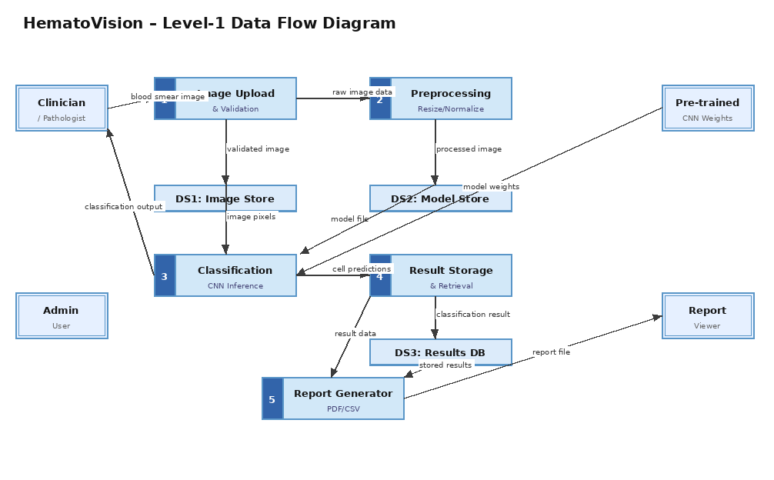
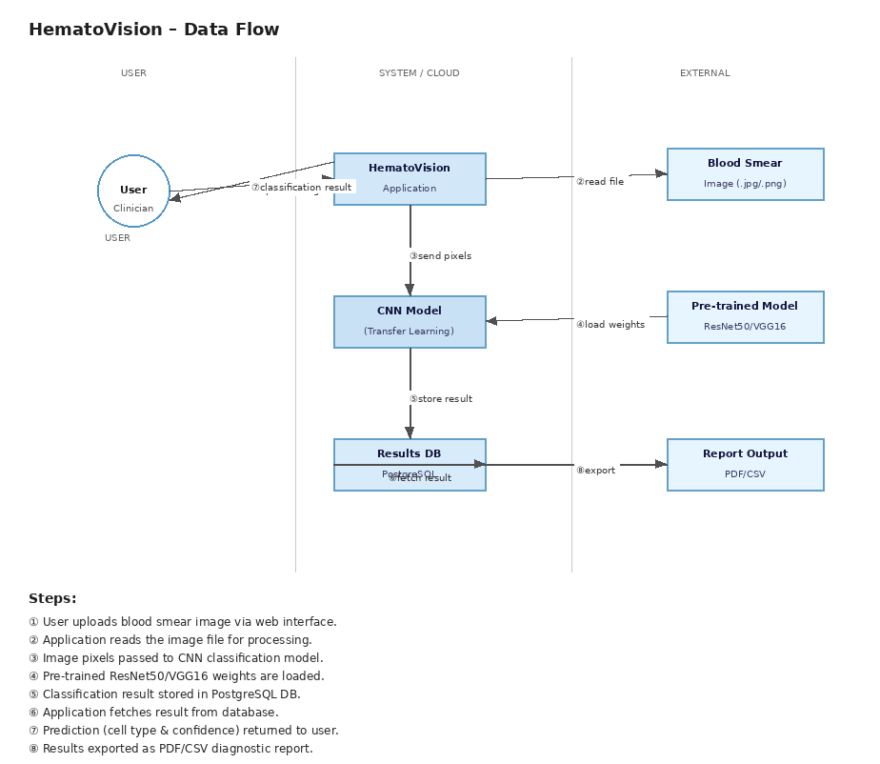

User Stories
Use the below template to list all the user stories for the product.
User Type | Functional Requirement (Epic) | User Story Number | User Story / Task | Acceptance criteria | Priority | Release
Clinician | Image Upload | USN-1 | As a clinician, I can upload a blood smear image (JPG/PNG) to the HematoVision system for classification. | Image is accepted and queued for processing; confirmation message displayed. | High | Sprint-1
 |  | USN-2 | As a clinician, I can view the classification result (cell type and confidence score) after the image is processed. | Classification result is shown within 5 seconds with accuracy ≥ 90%. | High | Sprint-1
 |  | USN-3 | As a clinician, I can download a diagnostic report in PDF/CSV format for the classified blood cell image. | Report is generated with cell type, confidence, and timestamp; downloadable. | Medium | Sprint-2
Pathologist | Classification | USN-4 | As a pathologist, I can review AI-classified blood cells and override incorrect predictions with my own label. | System records both AI prediction and manual override; accuracy improves over time. | High | Sprint-2
 | Result Review | USN-5 | As a pathologist, I can filter and search previous classification results by date, cell type, or patient case ID. | Results are retrievable via filters; list loads in under 2 seconds. | Medium | Sprint-2
 | Dashboard | USN-6 | As a pathologist, I can view a dashboard summarising classification statistics (e.g., cell type distribution charts). | Dashboard displays charts and summary stats updated in real time. | Medium | Sprint-3
Lab Manager | Report Management | USN-7 | As a lab manager, I can access all classification reports across the team and export bulk data for audit purposes. | Bulk export as CSV works for up to 10,000 records; role-based access enforced. | High | Sprint-2
Lab Manager | Quality Control | USN-8 | As a lab manager, I can flag low-confidence predictions (< 70%) for mandatory human review before finalising. | Low-confidence cases are highlighted and cannot be finalised without pathologist sign-off. | High | Sprint-3
Administrator | Model Management | USN-9 | As an admin, I can upload and activate a new transfer learning model version to replace the current deployed model. | New model is deployed with zero downtime; rollback option available. | High | Sprint-3
Administrator | User Management | USN-10 | As an admin, I can create, edit, and deactivate user accounts and assign roles (Clinician/Pathologist/Lab Manager). | Role changes take effect immediately; audit log updated. | High | Sprint-1
Administrator | System Monitoring | USN-11 | As an admin, I can monitor system performance metrics (CPU, inference latency, model accuracy) via an admin panel. | Metrics refresh every 30 seconds; alert triggered if latency > 10s. | Medium | Sprint-3
Administrator | Data Security | USN-12 | As an admin, I can configure data retention policies and ensure all blood cell images are encrypted at rest. | Images stored with AES-256 encryption; retention policy configurable per institution. | High | Sprint-1

